Xinyu (David) Liu
Modern Instrumentation 327
Lab 6: Two Difference Amplifiers

Background:

The two circuits in this lab, the difference amplifier and instrumentation amplifier, both take the difference between two input voltages and multiply it in Vout by a certain factor, called the gain. The difference amplifier (see below, figure 2) has two voltages applied to the inverting and non-inverting amplifiers of an op-amp.

In this lab, R1 will be set equal to R2 and R3 = R4. Consequently it can be described by the equation Vout = R3 / R1 * ( V2 – V1). Rearranging this slightly, we have: gain = R3 / R1, since (V2 – V1) is effectively the input voltage. Since gain depends on the ratio of the resistances, it can get quite large, which is why either a bridge circuit or a simple voltage divider can be used to provide a smaller Vin. Bridge circuits often use thermistors; resistances that change rapidly with temperature. They can be described with the equation Rtherm = R₀ exp (-αT_{c}), where R_{therm} is the resistance at temperature T_{c} (in Celsius) and R₀ is the temperature at 0 celsius.

A more complicated amplifier is the instrumentation amplifier, in figure 3 below. It has three op-amps and the same number of inputs and outputs as the difference amplifier. However, unlike the former, this circuit’s gain does not depend on what specific resistors each one is, but on the ratios of the resistances. Specifically, the equation involves the ratios k and a in the diagram: gain = -k ( 1 + 2a). This equation describes the condition that V1 will be from a voltage source such as a power supply or function generator and V2 is grounded.

At low enough voltages, both the difference amplifier and the instrumentation amplifier will behave as expected with the expected gain, but when it is increased, the gain will drop off steadily since they act similar to a low pass filter.

Methods:

Part 1: Difference Amplifier
A bridge circuit was set up like the one in Figure 1, with RB1 = RB2 = RB3 = 2.7kΩ. RB4 was a 5k potentiometer in series with a 1kΩ resistor.
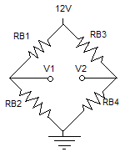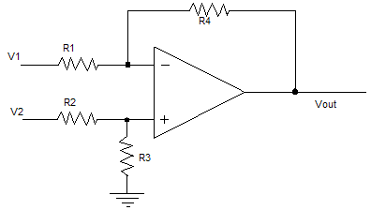
Figure 1: Bridge circuit Figure 2: Difference Amplifier

A difference amplifier (figure 2) was built with the center terminals of the bridge circuit as input.

The resistors used were R1 = R2 = 10kΩ and R3 = R4 = 100kΩ, in order to have a gain of 10 (see background for formula). Offset voltage was measured when V1 – V2 = 0, and offset was subtracted from all further measurements in part 1.

Output voltage was measured for several different (V1 – V2) values, ranging from -0.8V to 0.8 V. This was repeated with a voltage divider with Vout providing V1 for the amplifier and V2 as ground. Finally, while V2 was ground, V1 was set to be a sine wave with amplitude 0.5V, and output was observed as frequency was adjusted.

Part 2: Instrumentation Amplifier

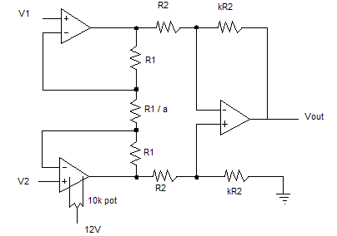

Figure 3: instrumentation amplifier

The circuit in Figure 3 was built using R1 = 5k, R2 = 15k, k = 1 and a = 5 in order to have a total gain of 10 (see Vout formula in background). A DC offset was measured with V1 – V2 = 0, and a potentiometer was adjusted until offset was 0.

Gain as a function of input voltage was measured with a 5 khz V1, and V2 = 0. Also, frequency dependence of gain was measured from 1kHz to 1MHz.

Part 3: Thermistor temperature dependence

Another bridge circuit (figure 1) was built using RB1 = RB3 = 470k, RB2 = 270K, and RB4 a 330k resistor in parallel with a thermistor. The thermistor was first measured at room temperature with the resistance meter and then placed in freezing water and measured again.

After holding the thermistor for a minute or two, it was placed in the bridge and Vout in the amplifier was measured.

Results:

Part 1:
Offset output: 0.05V (already subtracted from all subsequent measurements)
Bridge |  |  | Voltage divider
V1 - V2 (V) | Vout (V) |  | V1 - V2 (V) | Vout (V)
-0.79 | -7.87 |  | -0.82 | 7.97
-0.5 | -4.97 |  | -0.51 | 5.03
-0.25 | -2.47 |  | 0.29 | -3
0.25 | 2.4 |  | 0.39 | -3.95
0.5 | 4.9 |  | 0.56 | -5.44
0.8 | 7.95 |  | 0.61 | -6
Figure 4: Bridge linearity Figure 5: Voltage divider output linearity
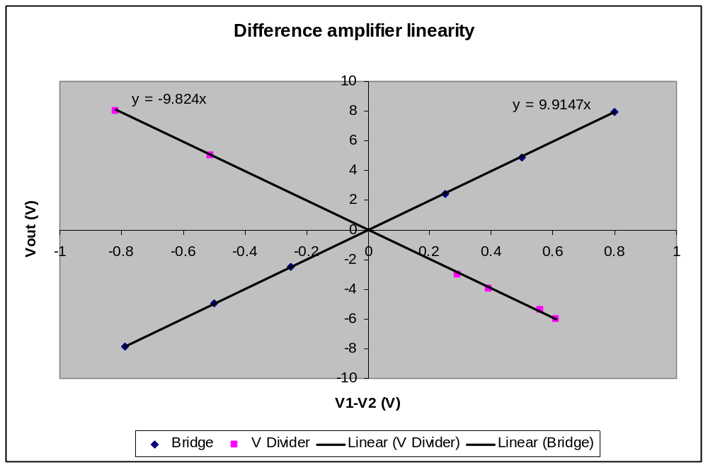
Figure 6: Difference amplifier linearity

As seen in figures 4-6, the output voltage of the difference amplifier is very linear and has a very high correlation. The slopes of the two lines are both very close to the originally intended gain of 10. The bridge had a positive slope of 9.91, while the voltage divider had a negative slope of -9.82. This is because V1 of the voltage divider enters the inverting (-) of the op-amp, while the V2 is ground, so Vout is inverted to about negative 10 times Vin.

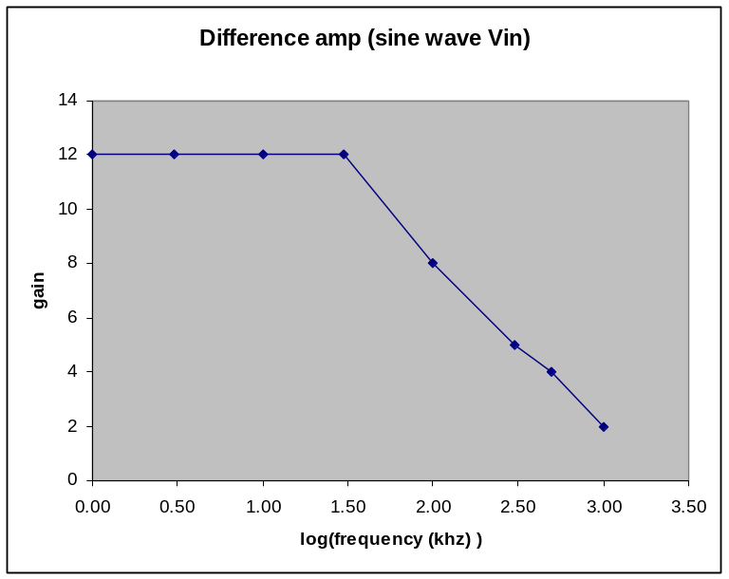
Next, Vin was attached to a function generator and gain was measured at various frequencies.
Sine wave Vin
Freq (kHz) | Log(freq) | Gain
1 | 0.00 | 12
3 | 0.48 | 12
10 | 1.00 | 12
30 | 1.48 | 12
100 | 2.00 | 8
300 | 2.48 | 5
500 | 2.70 | 4
1000 | 3.00 | 2

Figure 7: Difference amp with sine wave (Vin)
From figure 7, it appears that gain is steadily at 12 at low frequencies. As soon as it reaches 30khz, the gain dips steadily, almost linearly toward 0. The corner frequency, the frequency where it starts dipping, appears to be around 30kHz. The gain-frequency relationship very strongly resembles one of a low pass filter. Both have a first order drop off after the frequency increases above the corner.

Part 2: Instrumentation Amplifier

Offset voltage: 0.13V (potentiometer was then adjusted so offset = 0)
Gain at 10 khz |  |  |  | Gain at different frequencies
V1 | Vout | Gain |  | freq (khz) | log(freq) | Gain
0.17 | 1.82 | 10.71 |  | 1 | 0 | 10.85
0.24 | 2.56 | 10.67 |  | 10 | 1 | 10.85
0.4 | 4.45 | 11.13 |  | 50 | 1.69897 | 9.33
0.67 | 6.91 | 10.31 |  | 100 | 2 | 6.77
0.95 | 9.96 | 10.48 |  | 200 | 2.30103 | 3.85
1.22 | 13.04 | 10.69 |  | 500 | 2.69897 | 1.52
1.4 | 15.2 | 10.86 |  | 1000 | 3 | 0.58

Figure 8: Gain at low frequency Figure 9: Gain at different frequencies

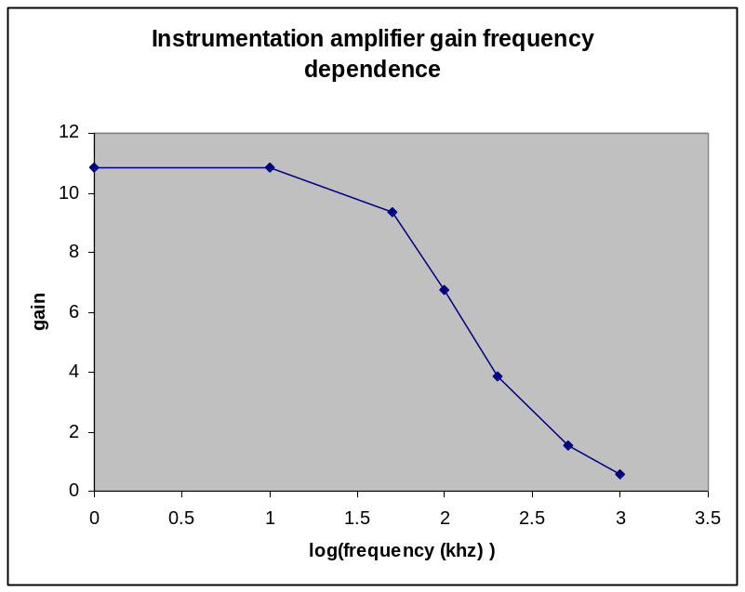
Figure 10: gain at different frequencies plot

In figure 8, unsurprisingly the gain does not vary at all with Vin. At every value of Vin measured, gain was more or less the expected value of 10 (since the resistors were set up to have a gain of -1(1 + 2 * 5) = 11. As expected, gain does not depend on V1 anymore than Vout does. When frequency is increased however, that changes drastically, as in figure 9. The plot of the gain at different frequencies resembles a low pass filter but the drop off is not as linear, and there isn’t a very clear corner frequency.

Part 3: Thermistor temperature dependence

At 0°C, Rt = 14.2k
1 / RB4 = 1 / 14.2k + 1 / 330k (RB4 = thermistor in parallel with 330k);
RB4 = 13.6k

At 20°C, Rt = 4.7k
1 / RB4 = 1 / 4.7k + 1 / 330k (RB4 = thermistor in parallel with 330k);
RB4 = 4.6k

RB2 necessary to achieve null (V1 – V2 = 0) at room temperature:
Using RB1 / RB2 = RB3 / RB4 when V1 – V2 = 0;
470k / RB2 = 470k / RB4;
RB2 = RB4 = 4.6k

R_{therm} = R₀ exp(-α * T_{c});
4.7k = 14.2k exp(-α * 20°C);
4.7k / 14.2k = exp(-α * 20°C);
-1.106 = -α * 20°C;
α = 0.0553

After holding thermistor in hand for 2 minutes, Vout was measured to be 8.23 V.
Normal body temperature is 37°C. At 20°C, Vout was measured to be 3.5V. First, if it is assumed that Vout is proportional to temperature, then Vout at body temperature would be calculated to be 37 / 20 * 3.5 = 6.48V, or a bit below the measured value of 8.23V.
Second, the resistance of the body temperature thermistor was measured to be 2.42k. Using the thermistor formula, Tc = ln ( R_{therm} / R₀ ) / -α, Tc was calculated to be 32.1°C.

The first assumption underestimated Vout while the second assumption underestimated Tc. A likely explanation is that the thermistor cooled in the time between letting it go and recording Vout.

Conclusion:
Even though difference amplifiers and instrumentation amplifiers have different gain equations, they behave similarly. With DC voltage, both difference and instrumentation amplifiers have Vout values that agree linearly with the expected gain from their equations, no matter what Vin is. This is also true for AC voltage at low frequencies, but when the frequency is increased beyond a certain point, the gain decreases steadily towards zero. The thermistors used to divide the input voltage in the bridge circuits had an inverse relationship between temperature and resistance. With 0 celsius as the reference temperature, Vout and gain increased with temperature.

